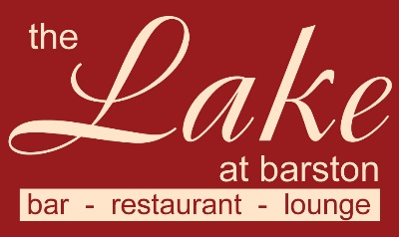
Christmas Festive Gold Menu 2023
3 courses £28.95 pp (v – vegetarian, vg – vegan, gf – gluten free, cn – contains nuts)
A pre order will be required 1 week before the event

Starters
Winter Vegetable Broth (v, vg, gf)
Rose of Melon, with Passionfruit and Raspberry Coulis (v, vg, gf)
Button Mushrooms in a creamy Garlic & White Wine sauce (v, gf)
Baked English Brie with Cranberry & Apple Compote (v)

Main Courses
Roast Breast of Turkey served with Bacon wrapped Chipolata, Stuffing, Roast Potatoes, Vegetables & Gravy
Seared fillet of Salmon served with Dill Cream sauce, New Potatoes & Vegetables (gf)
Roasted Loin of Bacon served with New Potatoes, Winter Greens, and Parsley sauce (gf)
Slow roasted Rump of Lamb with Mashed Potato, Minted Gravy & Vegetables (gf)
Root Vegetable Hot Pot served with Winter Greens (v, vg, gf)
Desserts
Christmas Pudding with Brandy sauce (v, cn)
Strawberry Cheesecake with White Chocolate sauce (v)
Mince Pie Ice Cream Sundae (v, cn)
Fresh Fruit Salad (v, vg, gf) with pouring Cream (v, gf)

The Lake at Barston, Solihull, West Midlands 01675 444890

