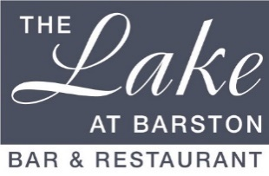

Sunday Lunch Large Party Sample Menu 2023

This menu is for parties of 10 and above.
3 Course pre-paid price - £27.50 per person.

(v –vegetarian, vg – vegan, gf – gluten free, cn - contains nuts, df – dairy free - further allergy information available on request)

Starters

Homemade Vegetable Soup (v, vg, gf)

Duo of Melon with Dragonfruit and Champagne Sorbet (v, vg, gf)

Atlantic Prawn Cocktail with Marie Rose sauce (gf)

Farmhouse Pate with Ale Chutney and Ciabatta

************************
Mains

Breast of Turkey with Stuffing, Carrots, Beans, Parsnip, Cabbage, Roast Potatoes

Roast Sirloin of Beef, Yorkshire Pudding, Carrots, Beans, Parsnip, Cabbage, Roast Potatoes

Turkey & Beef – 50/50 Meat with Stuffing, Carrots, Beans, Parsnip, Cabbage, Roast Potatoes

Mushroom Stroganoff, Rice, Sour Cream & Garnish (v, gf)

Mediterranean Vegetable Casserole with Rice (v, vg, gf)

Desserts

Hot Apple Pie with Custard (v, cn)

Vanilla Cheesecake with Forest Berries (v)

Lemon Meringue Ice Cream Sundae (v, gf)

Fresh Fruit Salad (v, vg, gf) with Pouring Cream (v, gf)

Vanilla Ice Cream (v, gf)

Mixed Ice Cream (v, gf)

Cheese and Biscuits (v)

We kindly ask that all Children are supervised at all times, Thank you

