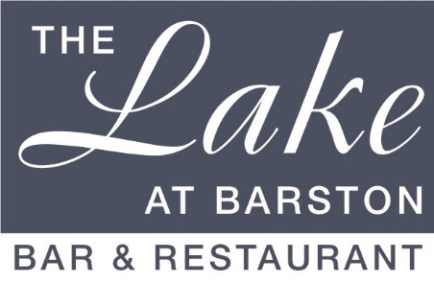

Funeral Wakes 2024-2025
Available midweek days, 30 – 200 people

Menu A - £20.00 per person

Assorted Sandwiches;
Ham & Tomato, Cheese & Onion, Turkey & Cranberry on White bread,
Tuna & Cucumber and Egg & Cress on Brown bread.

Warm Quiche, Chicken strips, Sausage rolls, Chips & Crudités with dips (v)

* * * * *
Scones with Clotted Cream & Jam

* * * * *
Tea and Coffee

If you would like to amend the menu we would be happy
to create a bespoke menu to your requirements.

